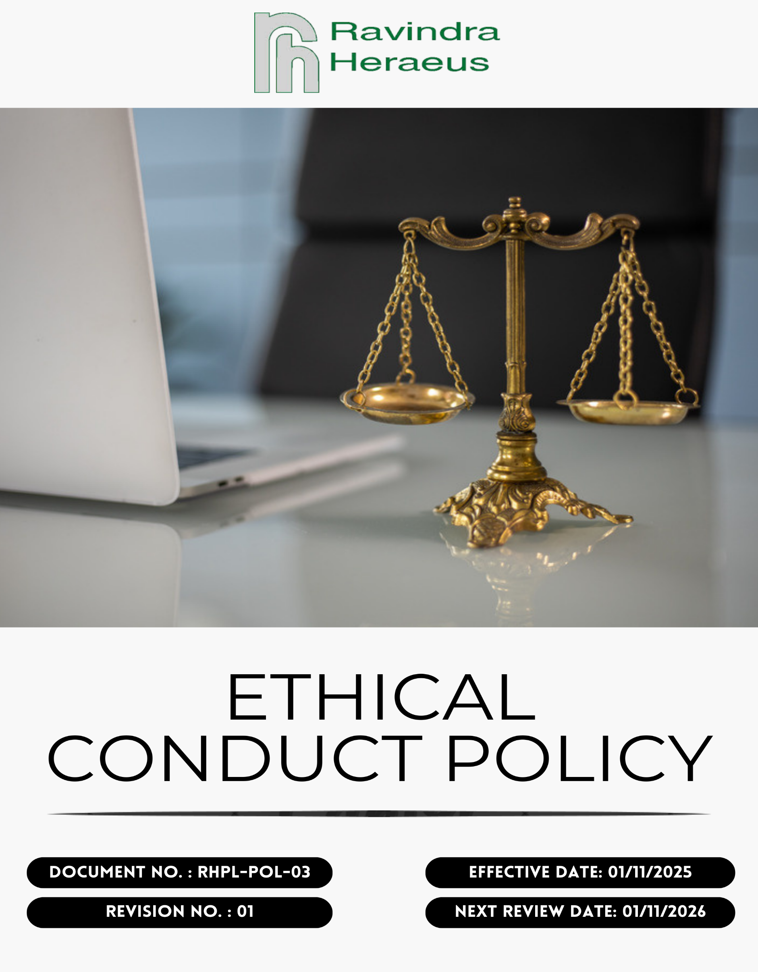
Contents

Preface 3
Policy Declaration 3
Scope 3
Key Focus Areas 4
Qualitative Objectives 4
Quantitative Targets 5
Alignment with the United Nations Sustainable Development Goals (SDGs) 6
Examples and Guidance 7
Continuous Improvement 8
Addressing Policy Violations 9
Responsibilities 9
Review Mechanism 10
Employee Acknowledgment Form 11

Preface
At RHPL, we are committed to conducting our business with the highest standards of integrity, transparency, and ethical behavior. Our reputation is built on scientific excellence, customer trust, and ethical responsibility. Our Ethical Conduct Policy serves as the cornerstone of our corporate culture, guiding our interactions with employees, customers, suppliers, and the communities we serve. We uphold principles of fairness, accountability, and respect, ensuring that our business practices reflect our dedication to ethical excellence and social responsibility. We are dedicated to ensuring that all employees and stakeholders act with fairness, honesty, and respect while complying with applicable laws, regulations, and industry best practices. Our goal is to create an environment where ethical behavior, mutual respect, and responsible business practices are an integral part of everyday operations.

Policy Declaration
RHPL is committed to maintaining the highest standards of ethical conduct in all aspects of our operations. We pledge to act with integrity, transparency, and accountability in our interactions with employees, customers, suppliers, and the communities we serve. Our ethical principles guide our decision-making processes, ensuring compliance with applicable laws and regulations, and fostering a culture of trust and respect. We are dedicated to continuous improvement, promoting ethical awareness among our stakeholders, and addressing any concerns promptly and effectively. Through this policy, we aim to reinforce our commitment to ethical excellence and corporate responsibility.

Scope
This Ethical Conduct Policy applies to all employees, contractors, and partners of RHPL It covers all aspects of our operations, including engineering, production, quality assurance, supply chain management, and customer relations. The policy extends to our interactions with external stakeholders, ensuring that our business practices reflect our commitment to integrity, transparency, and ethical excellence

Site | Address
Ravindra Heraeus Pvt. Ltd. | A -196 (A), F Road, Madri Industrial Area, Udaipur - 313001, Rajasthan, India.

Key Focus Areas
- Preventing Corruption: Strictly prohibit bribery, kickbacks, and any form of corrupt practices through clear policies, training, and enforcement.
- Conflict of Interest: Require disclosure and proper handling of personal or professional interests that may influence company decisions.
- Fraud: Prevent and detect fraud through internal controls, regular audits, and secure reporting mechanisms.
- Anti-Money Laundering: Comply with AML laws by verifying transactions, monitoring for suspicious activity, and training employees on red flags.
- Information Security: Safeguard sensitive data through robust cybersecurity measures, access controls, and regular employee awareness programs.
- Responsible Use of Company Assets: Use company resources efficiently and solely for lgitimate business purposes, avoiding waste or misuse.

Qualitative Objectives
- Preventing Corruption
- Maintain a zero-tolerance approach to bribery and corruption and comply with all applicable anti-corruption laws and internal policies.
- Conduct appropriate anti-bribery and corruption due diligence for mergers, acquisitions, joint ventures, and key business relationships.
- Foster a culture of integrity where employees are trained to recognize, prevent, and reject unethical practices.

- Conflict of Interest
- Encourage transparency by requiring employees to avoid and disclose situations where personal interests may conflict with RHPL’s business interests.
- Implement clear and fair procedures for identifying, disclosing, and managing conflicts of interest.
- Ensure all business decisions are objective, unbiased, and documented, including dealings with suppliers, customers, and partners.

- Fraud
- Enforce a zero-tolerance policy toward fraud and misconduct across all operations.
- Promote employee awareness, accountability, and timely reporting of suspicious or irregular activities.

- Anti-Money Laundering (AML)
- Raise employee awareness of AML responsibilities and the importance of monitoring transactions for unusual or suspicious activity.
- Ensure full compliance with applicable AML laws and prevent misuse of RHPL operations for illegal or unethical purposes.
- Encourage prompt reporting and investigation of any suspected AML concerns.

- Information Security
- Protect confidential business, employee, and customer information through robust information security controls and access management.
- Regularly review and strengthen data protection measures to address evolving cyber risks and regulatory requirements.

- Responsible Use of Company Assets
- Promote responsible, efficient, and ethical use of company assets and resources.
- Establish clear guidelines governing acceptable personal use of company property to prevent misuse or conflicts of interest.

Quantitative Targets
The FY 2022-23 serves as the baseline for all ethical governance targets at Ravindra Heraeus Pvt. Ltd., including those related to business integrity, anti-corruption, conflict of interest, fraud prevention, and anti-money laundering. Progress will be measured against this baseline to ensure continuous improvement through years with the targets set for FY 2029-30.

- Preventing Corruption
- Ensure inclusion and compliance of anti-bribery clauses into 100% of supplier and partner contracts by FY 2029-30.
- Train 100% of procurement and finance teams on anti-corruption policies annually.
- Maintain zero confirmed incidents of corruption across all operations.

- Conflict of Interest
- All reported conflict-of-interest cases are reviewed and resolved within 30 days of notification.
- Achieve 100% completion of Conflict of Interest disclosures by all managers by FY 2029-30.
- Ensure 100% of new employees complete Conflict of Interest orientation within one month of joining.

- Fraud
- Maintain an effective fraud detection and monitoring mechanism to achieve zero undetected fraudulent transactions by FY 2029-30.
- Conduct annual fraud risk assessments across all business functions.
- Maintain zero confirmed fraud-related incidents annually through preventive controls and timely corrective actions.

- Anti-Money Laundering (AML)
- Ensure 100% of employees in relevant roles complete AML training by FY 2029-30.
- Maintain zero instances of non-compliance with applicable AML laws and regulations through FY 2029-30.

- Information Security
- Ensure 100% of employees complete information security awareness training by FY 2029-30, covering data privacy, cyber risks, and phishing prevention.
- Achieve 100% compliance with annual information security audits across all departments.
- Maintain zero incidents of unauthorized data access or data breaches through strengthened controls and monitoring.

- Responsible Use of Company Assets
- Conduct quarterly reviews of company asset usage to ensure resources are used solely for legitimate business purposes.
- Maintain 100% compliance with company asset usage policies by FY 2029-30 through awareness and monitoring.

Alignment with the United Nations Sustainable Development Goals (SDGs)
The sustainability objectives and performance targets align with the following Sustainable Development Goals (SDGs):
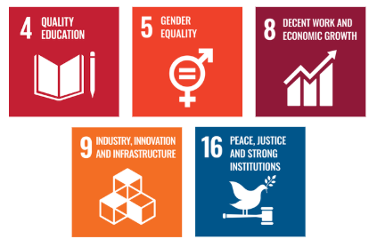

Examples and Guidance
To support consistent understanding and implementation of this Ethical Conduct Policy, the following topic-wise examples and guidance offer practical interpretations of expectations and actions:

- Preventing Corruption
- Example: A supplier offers luxury event tickets to influence a contract decision.
- Guidance: The employee must politely refuse the offer, document the incident, and report it to the compliance officer. Accepting such offers is strictly prohibited under anti-corruption policies. All dealings with suppliers must be conducted with complete transparency and objectivity.

- Conflict of Interest
- Example: A project manager is evaluating a vendor owned by their spouse.
- Guidance: The manager must disclose the relationship and recuse themselves from the selection process. All potential conflicts must be reported, and decisions must be made without personal bias or undue influence.
- Fraud
- Example: Duplicate vendor invoices are identified.
- Guidance: Flag the irregularity, initiate an investigation, and report findings promptly. Maintain financial transparency.

- Anti-Money Laundering
- Example: A customer requests splitting a large transaction to bypass reporting requirements.
- Guidance: This is a red flag for potential money laundering. The transaction must be reported and flagged for review as per AML protocols. Employees must be trained to recognize and respond to suspicious financial behavior.
- Information Security
- Example: Confidential client information is left in a public area.
- Guidance: Secure the data immediately, report the breach, and adhere to information protection protocols.

Continuous Improvement
At Ravindra Heraeus Pvt. Ltd., Ethical Conduct practices are continuously enhanced to stay aligned with evolving regulations, industry standards, and emerging risks. A strong culture of integrity is embedded across all levels of the organization, ensuring transparency, accountability, and regulatory compliance.

- Ongoing Training & Awareness: Annual training for employees, suppliers, and contractors on ethics, compliance, labor rights, environment, information security, and anti-corruption.
- Risk Assessments & Independent Audits: Periodic risk assessments across operations and supply chains helps to identify potential issues related to labor, safety, environment, ethics, and data protection. Implement corrective action plans (CAPs) and track remediation progress.
- Collaborative Compliance Engagement: Work with partners to strengthen compliance via shared tools, training, self-assessments, and joint capacity-building.
- Advanced Monitoring & Reporting Systems: Use digital dashboards and analytics to monitor compliance and identify trends.
- Feedback & Transparency Culture: Open, retaliation-free reporting channels—supported by continuous feedback and transparent compliance sharing—enable employees and partners to voice concerns, driving ongoing refinement of our policies and practices.

Addressing Policy Violations
Ravindra Heraeus Pvt. Ltd. maintains a zero-tolerance approach toward violations of its Ethical Conduct Policy. All suspected or confirmed breaches will be handled seriously, fairly, and in a timely manner to uphold the company’s values of integrity, transparency, and accountability.
- Reporting Violations: Employees, contractors, suppliers, and stakeholders are encouraged to report misconduct via supervisors, compliance channels, or confidential whistleblower system. Anonymous reporting is allowed.
- Investigation Process: All reports are logged and investigated impartially by internal compliance or independent experts with confidentiality and transparency.
- Corrective Actions: When a violation is confirmed, the company will take appropriate disciplinary action based on the severity of the offense. This may include formal warnings, mandatory retraining, suspension, reassignment, or termination of employment. For example, an employee found accepting unauthorized payments from vendors may face immediate dismissal and legal prosecution.
- Protection from Retaliation: Any form of retaliation against individuals who report concerns or assist in investigations is strictly prohibited. Whistleblowers are fully protected, and anyone engaging in retaliatory actions will face disciplinary measures.

Responsibilities
At Ravindra Heraeus Pvt. Ltd., upholding ethical conduct is a collective responsibility:
- Compliance Officer: Monitor compliance, investigate concerns, maintain records, and provide guidance.
- HR Manager: Promote ethical culture, ensure training, manage reporting and disciplinary processes.
- IT Manager: Safeguards all types of data through secure information systems.
- Internal Audit Team: Conduct audits, investigate breaches, maintain records, and recommend improvements.
- Senior Management: Foster integrity, transparency, and accountability; ensure compliance; provide resources for training and continuous improvement.
- Employees: Act ethically, disclose conflicts, report violations, and complete mandatory compliance training.

Review Mechanism
The Ethical Conduct Policy is reviewed annually by the Compliance Officer to ensure its continued relevance, effectiveness, and alignment with legal and regulatory requirements. Updates may be made based on audit findings, changes in applicable laws, employee feedback, or evolving business practices. Any revisions are communicated to all employees, and necessary training is provided to ensure awareness and compliance.
Effective Date | : 01.11.2025
Next Review Date | : 01.11.2026
Revision No. | : 01

Approved By:

Employee Acknowledgment Form
I acknowledge that I have received, read, and understood the Ethical Conduct Policy of Ravindra Heraeus Pvt. Ltd. to uphold the principles set forth in the policy, including preventing bribery and corruption, identifying and disclosing conflicts of interest, preventing fraud, complying with anti-money laundering regulations, and protecting confidential company and client information.
I understand that it is my duty to follow this policy in all professional conduct and to report any suspected violations or unethical behaviour through the company’s confidential whistleblower system or other designated channels. I am aware that any breach of this policy may result in appropriate disciplinary action agree as per company guidelines.
By signing this declaration, I confirm my personal commitment to maintaining ethical behaviour, accountability, and transparency in all my responsibilities at Ravindra Heraeus Pvt. Ltd.

Employee Name | :
Employee ID | :
Department | :
Signature | :

